PROJECT | AI-ENHANCED DEPARTMENTAL STORE MANAGEMENT SYSTEM
NAME | - ZAINAB SARFRAZ  - ADEEN TARIQ  - EMAN QASIM
REG NO | - 24-NTU-CS-FL-1289  - 24-NTU-CS-FL-1242  - 24-NTU-CS-FL-1255
SEMESTER | 3rd
COURSE CODE/TITLE | COC-2079L/Introduction to Artificial Intelligence - LAB
SECTION/DEPARTMENT | BSAI/CS
SUBMITTED TO | MAM. KAINAT ABDULLAH
SUBMISSION DATE | 2nd January, 2026


AI-ENHANCED DEPARTMENTAL STORE SYSTEM
PROJECT OVERVIEW:
The AI-Enhanced Departmental Store Management System is designed to efficiently manage departmental store operations using Python. This system integrates basic AI concepts such as sales analysis, demand prediction, product recommendations, and supply forecasting to improve store management.
Key Roles:
- Admin: Manages products, stock, and prices.
- Manager: Monitors sales, stock levels, and predicts future demand.
- Customer: Purchases products and receives AI-based recommendations.
- Supplier: Supplies products based on AI-generated suggestions.
INTRODUCTION:
The AI-Enhanced Departmental Store Management System is a Python-based application designed to make store operations smarter and more efficient. It allows different users — Admin, Manager, Customer, and Supplier — to interact with the system according to their roles.
Using basic AI techniques, the system can:
- Analyze sales and predict product demand.
- Recommend products to customers based on their past purchases.
- Suggest supply quantities to suppliers for better inventory management.
This project demonstrates how AI concepts can be applied to real-world business scenarios to improve decision-making and enhance customer experience.
PROBLEM STATEMENT:
Managing a departmental store manually can be difficult and time-consuming. Problems like keeping track of stock, predicting which products will sell, recommending items to customers, and planning supply often occur.
This project aims to solve these problems by creating an AI-Enhanced Departmental Store System that:
- Tracks products and stock automatically.
- Helps managers analyze sales and predict demand.
- Recommends products to customers based on their past purchases.
- Suggests supply quantities to suppliers.
The system makes store management faster, smarter, and more efficient.
OBJECTIVES:
The main objectives of the AI-Enhanced Departmental Store System are:
- Efficient Inventory Management: Keep track of products and stock automatically.
- Sales Analysis: Help managers see which products are selling well.
- Demand Prediction: Predict how much of each product will be needed in the future.
- Customer Recommendations: Suggest products to customers based on their past purchases.
- Supply Planning: Help suppliers know how much stock to provide.
- User-Friendly System: Make it easy for Admin, Manager, Customer, and Supplier to use.
TECHNICAL IMPLEMENTATION:
The AI-Enhanced Departmental Store System is implemented using Python and uses basic AI techniques to improve store management. The technical details are:
- Programming Language: Python
- Data Structures Used:
  - Dictionary: Stores product details like name, price, stock, and sales.
  - List: Tracks customer cart and purchase history.
- Functions: Each role (Admin, Manager, Customer, Supplier) has separate functions for their tasks.
- Conditional Statements & Loops: Used for menu navigation, decision-making, and repeating tasks.
- Built-in Functions:
  - sum() → Calculates total sales or demand.
  - round() → Rounds demand predictions.
  - sorted() → Sorts products based on sales for recommendations.
- User Interaction: Uses input() to get choices and quantities from users.

- AI Features Implemented:
  - Sales Analysis: Calculates total sales for products.
  - Demand Prediction: Computes average demand using past sales.
  - Product Recommendations: Suggests items to customers based on previous purchases or popularity.
  - Supply Prediction: Suggests supply quantities for suppliers using simple AI calculations.
The system is role-based, modular, and interactive, allowing different users to perform their tasks efficiently while integrating simple AI to enhance decision-making.
SYSTEM FEATURES:
The AI-Enhanced Departmental Store System includes the following features for different users:
- Admin Features:
- View Products: See all products with price and stock.
- Add Product: Add new products to the inventory.
- Restock Product: Increase stock quantity of existing products.
- Manager Features:
- Low Stock Report: Alerts when stock is low.
- Sales Analysis: Shows total sales of each product.
- Demand Prediction: Predicts average demand for products using past sales data.
- Customer Features:
- View Products: Browse available products.
- Buy Products: Purchase products and update stock automatically.
- Product Recommendations: Suggests products based on previous purchases or popular items.
- View Bill: Generates a bill including subtotal, tax, and total amount.
- Supplier Features:
- View Products: See current stock and product details.
- Supply Products: Suggests supply quantities based on past sales and adds stock accordingly.
These features make the system efficient, smart, and easy to use for everyone involved.
EXPECTED OUTCOMES:

The AI-Enhanced Departmental Store System is expected to provide the following benefits:
- Efficient Store Management: Products, stock, and sales are tracked automatically.
- Better Decision Making: Managers can analyze sales and predict demand accurately.
- Improved Customer Experience: Customers receive product recommendations based on their preferences.
- Optimized Supply: Suppliers can provide the right quantity of products, reducing shortages or overstock.
- Time-Saving: Reduces manual work and speeds up store operations.
- AI Integration: Demonstrates practical use of AI in everyday business scenarios.

AI ENHANCEMENTS:
- Sales Analysis: Calculates total sales per product.
- Demand Prediction: Computes average demand for products.
- Product Recommendations: Suggests products based on purchase history.
- Supply Prediction: Simple AI forecasts for supplier quantities.

SAMPLE OUTPUTS:

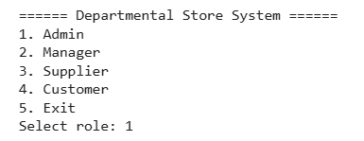

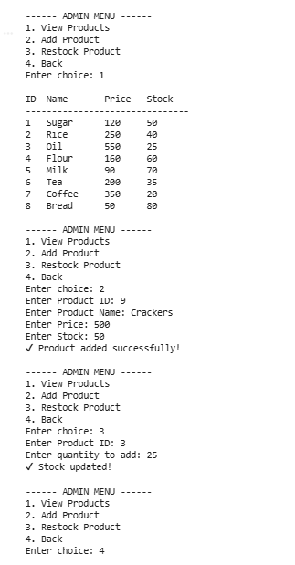

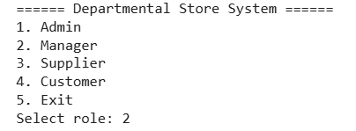

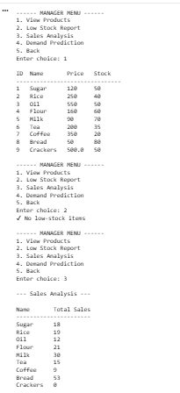

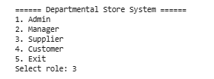

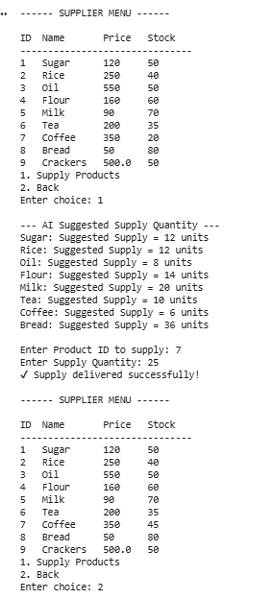

CONCLUSION:
This project demonstrates how AI concepts can enhance traditional store management by:
- Improving inventory control.
- Predicting product demand.
- Offering personalized customer recommendations.
- Helping suppliers optimize supply.
It combines Python programming with practical AI applications to create a smart departmental store system.
PROJECT ROADMAP:
- Problem Understanding
- Python Fundamentals
- Data Collection and Storage
- Inventory Management Module
- Sales Management Module
- Data Analysis
- AI Model Development
- Decision Support System
- Testing and Validation
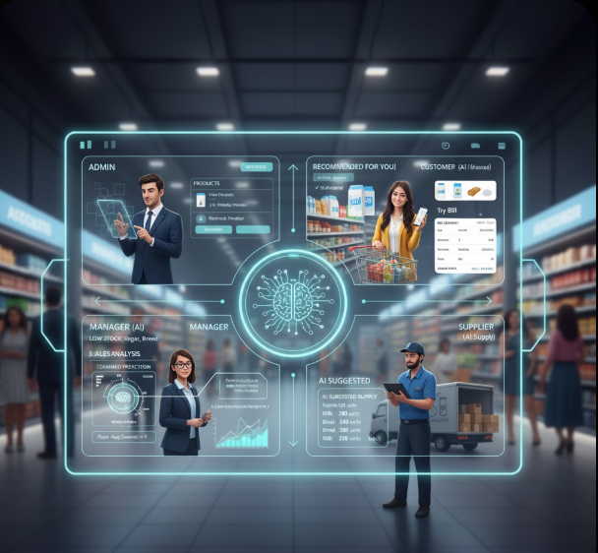
THE END

